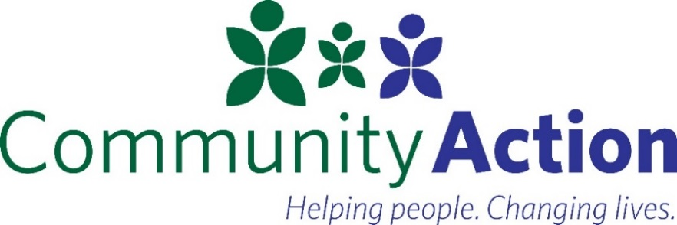

Services include:
-Career Coaching:
Job search tools and one on one coaching.

-Training & Education:
Gain new skills through training for specific jobs.

-Job Search & Placement:
Connections with employers and industries for jobs for which you qualify.

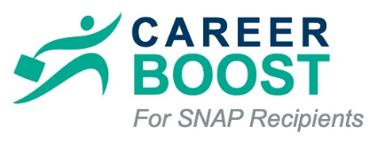
In partnership with WorkSource Beaverton-Hillsboro, Community Action provides Career Boost career coaching and career development programs for SNAP recipients.

To get started, please contact:
Jazmin Castro
Career Coach - Career Boost
Email: Jcastro@caowash.org
Office: 971-722-2609 Cell: 971-777-4581
WorkSource Beaverton-Hillsboro,
241 SW Edgeway Dr., Beaverton OR 97006

For more information about Career Boost, please visit: careerboost.worksourceportlandmetro.org

Los servicios incluyen:
- Guía de Carreras:
Herramientas de búsqueda de empleo y entrenamiento uno a uno.

-Preparación y Educación:
Obtenga nuevas habilidades a través de entrenamiento para trabajos específicos

-Búsqueda y Colocación de trabajo:
Conexiones con empleadores e industrias para los trabajos que califica.

En asociación con WorkSource Beaverton-Hillsboro, Community Action ofrece Career Boost guía de carreras profesionales y programas de desarrollo profesional para beneficiarios de SNAP

Para comenzar, contáctese con:
Jazmin Castro
Career Coach - Career Boost
Email: Jcastro@caowash.org
Office: 971-722-2609 Cell: 971-777-4581
WorkSource Beaverton-Hillsboro,
241 SW Edgeway Dr., Beaverton OR 97006

Para obtener más información acerca de Career Boost, visite: careerboost.worksourceportlandmetro.org

